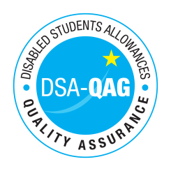
Leeds City College - NMH Rates

Period covered - 01/04/2020 through to 31/03/2021

The table below shows NMH rates. The greyed out cells indicate that the NMH provider does not offer these services.

Note: NMH Support Rates shown per hour in the table below.
 | Standard Rate (in-person) |  |  | Distance Learning only (in-person, in-home |  |  | Remote Delivery (e.g. FaceTime/Skype or similar) Only
Band 1 Support Assistants | Net | VAT | Total | Net | VAT | Total | Net | VAT | Total
Practical Support Assistant | 16.72 |  | 16.72
Library Support Assistant | 22.06 |  | 22.06
Reader | 16.72 |  | 16.72
Scribe | 16.72 |  | 16.72
Band 2 Enhanced Support Assistants
Examination Support Worker | 22.06 |  | 22.06
Band 3 Specialist Enabling Support
Band 4 Specialist Access and Learning Facilitators
Specialist 1:1 Study Skills Support - SpLD | 56.00 |  | 56.00
*Please delete any rows where you do not provide this support role

